- \(…)\ Version display
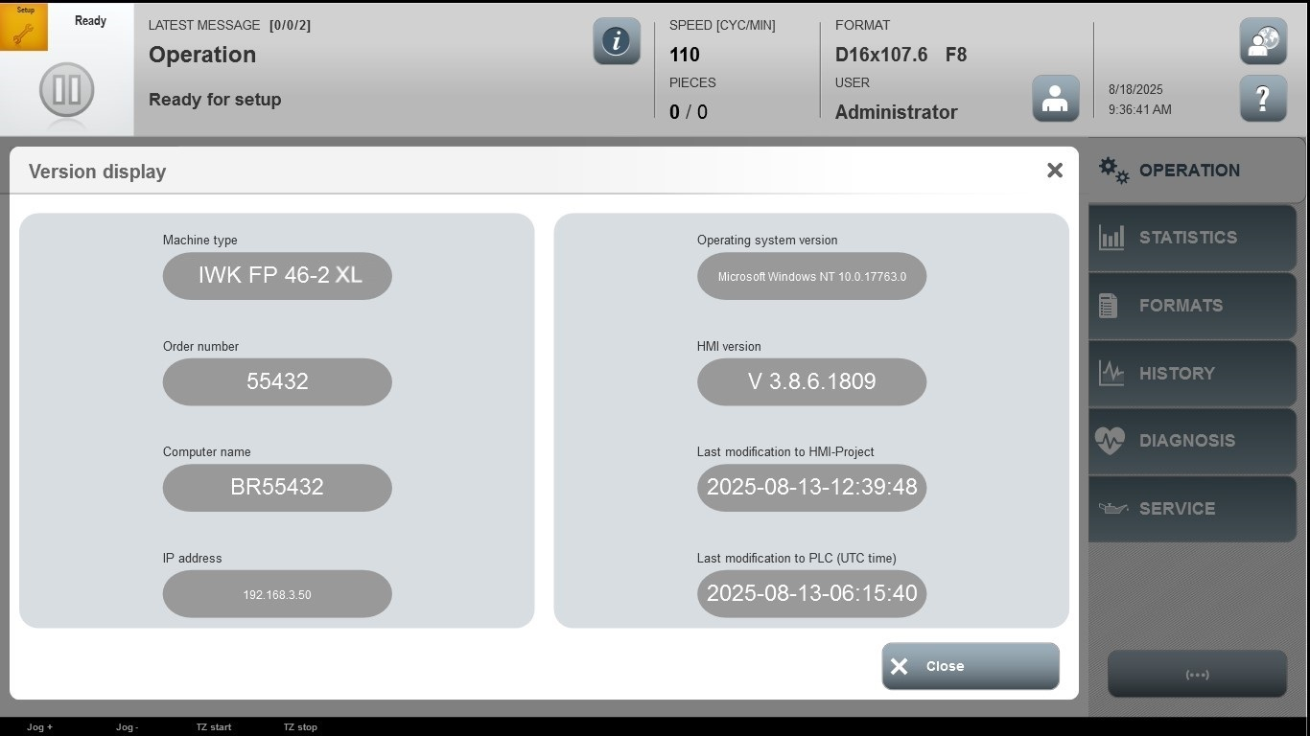
Acceptance criterion | Limits | Pass / Fail: Dev-No. | Date | Initials
Screen matches screenshot | N / A

- \(…)\Shutting down machine PC
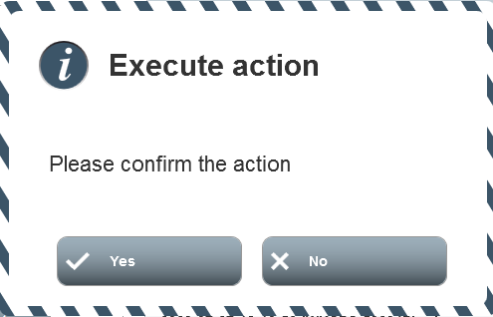 Example
Acceptance criterion | Limits | Pass / Fail: Dev-No. | Date | Initials
Screen matches screenshot | Depend of the machine

- \(…)\Touch calibration
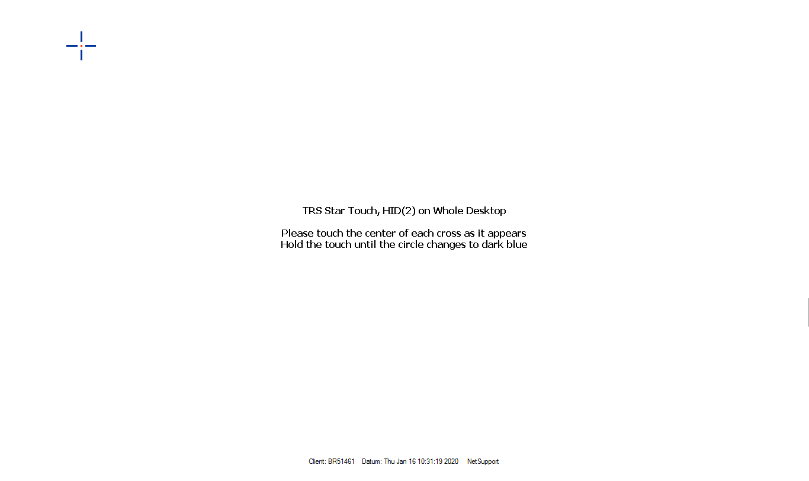
Acceptance criterion | Limits | Pass / Fail: Dev-No. | Date | Initials
Screen matches screenshot | Depend of the machine

